Nombre: ____________________________ Bloque: ________ Fecha: _______________________
Espanõl 2 - Unidad 3 – La cultura – Puerto Rico
Instrucciones: Fill out the following notes sheet based on the cultural activities online. This follows the online activity in order by section. Make sure to hold on to this paper to study, as this information will be part of the exam! This can also be used as a backup should you lose internet connection while working.

Vocabulario Importante:
Write the English meaning of the following words.
- Taíno: Native tribe of Puerto Rico
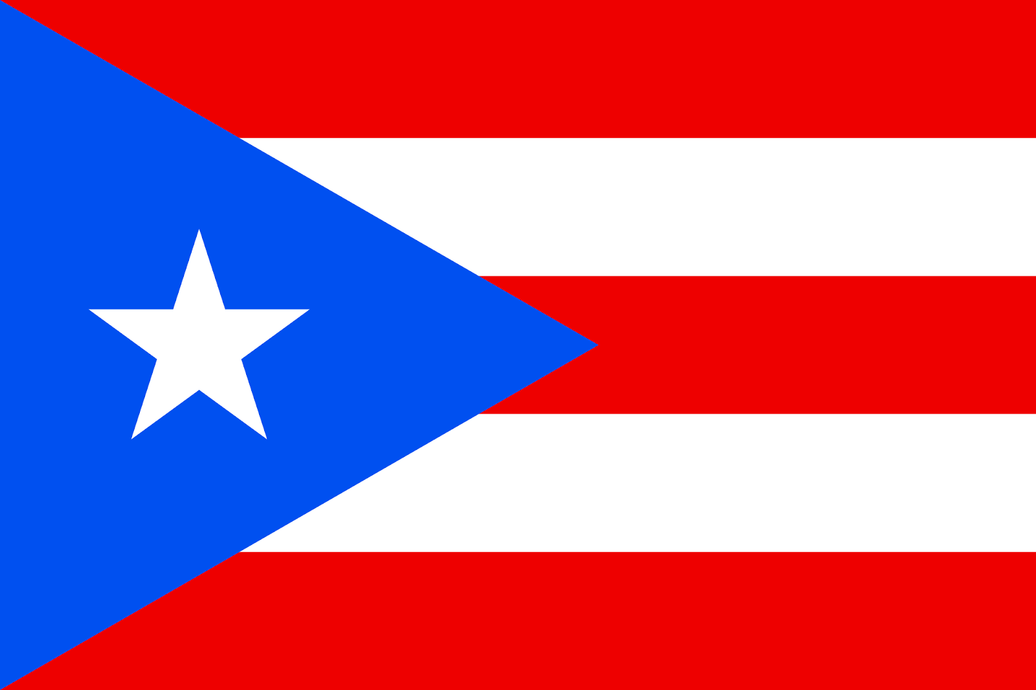
- Boricua: __________________________
- un timbal ____________________________
- el vejigante: folkloric character in Puerto Rican celebrations, wearing brightly colored ornate masks.
- un desfile: ____________________________
- una máscara: ____________________________
Colors/Design of the Puerto Rican Flag: ________________________
________________________
- indígena:_______________________________

Datos generales y geográficos:

- Capital of Puerto Rico: ____________________________
- Typical food: ____________________________
- Geographical form: an island
- Surrounding sea: ______________________________
- Countries to the West: ____________________________
- Countries to the South: Venezuela (South America)
- Currency used:____________________________
- Official languages: _____________________ and __________________________
- Puerto Rico is ___________________ of the US. They maintain their historic and cultural identity while still being US citizens.
- Puerto Ricans do not vote in _______________ or pay property taxes to the US government, but they do have a congressional delegate (though the delegate cannot vote).

Información general
Los Timbaleros y la música:
- A timbalero is ____________________________ and timbales are drums.
- Styles of music heard during festivals: _______________________________________________
- The use of percussion instruments by the timbaleros serve as a reminder of the ___________________ heritage of the island.
El Morro:
- A famous example of Spanish architecture in San Juan is ____________________________.
- The _______________________ began building el Morro in 1539 to ___________________ the island.

Los Taínos:
- Another name for Puerto Rico: __________________ and Puerto Ricans: ___________________
- Taínos are the _________________ people of Puerto Rico. These names come from a Taíno word for Puerto Rico.

El arte histórico:
- ________________________________ is the first well-known painter of Puerto Rico.
- He painted primarily ______________________ works (obras) and _________________________________________ of the 18th century (siglo XVIII).

Los centros comerciales:
- Plaza Las Americas is the largest mall in __________________________.
- Plaza Las Americas is located in __________________________.
- It is decorated with art that represents the ______________________ and ____________________ of Puerto Rico.
- ____________________ the largest mall in Lima, Perú, named after the nearby horse track.

Los vejigantes:
- Los vejigantes are people who wear traditional Puerto Rican __________________.
- You can see them in Ponce during ___________________________.
- The masks are painted bright colors and made of ______________________________ (cáscaras de coco) or
_______________________________.
- Los Vejigantes can be mischievous during parades trying to ____________ people.
- Los Vejigantes appears during _____________ en Ponce and the festival of _______________ (la Fiesta de Santiago Apóstol) in Loíza Aldea
- During these celebrations, musicians play ______________________, a style of dance music with ______________________ roots.
- During the celebrations, Los Vejigantes ____________________ and begin songs which people respond to with a rhyme.
Las parrandas:
- Las Parrandas are groups of people walking through the streets during the ________________________ season (temporada de Navidad).
- They sing ____________________ and play __________________________ often until dawn.
- Sometimes they stop to sing at a friend’s house to surprise them and wake them up. This is called ________________________________.
- Some songs request ______________________ and ____________________________.
- The family invites the parrandas in to _________________ and __________________________ and then joins the parranda to repeat this tradition with another family.

Las artesanías:
Las artesanías de Puerto Rico:
- Two traditional types of Puerto Rican handicrafts are _____________________ and _________________________.
- Las tallas de santos are carvings of saints, made of ________________________.
- Las casitas are miniature _________________________ of famous houses and buildings.

Las artesanías de Panamá:
- ____________________________ are large brightly-colored fabrics made by los cunas, an indigenous community of Panamá.
- In the town of La Arena, artisans make ________________ pieces using sand from the area that are unique.

